云尚生态公众号



云尚生态商户账号

账号1382171702

密码710158

商户回调key eYEDg3BDluzNVtKvj3y1GzkU4TVQ0vN5

公众号appid wxb0b79f2db57ddd6c

公众号secret d163f18a1b5d2d7379da644633f8964f

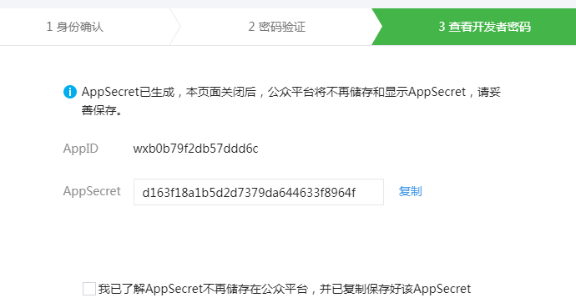

[**http://market.sunyoo51.com/admin**](http://market.sunyoo51.com/admin)

[**http://shop.sunyoo51.com/h5/weixinAuth**](http://shop.sunyoo51.com/h5/weixinAuth)



云尚生态配置备注

#### 业务域名

shop.sunyoo51.com

#### JS接口安全域名

#### sunyoo51.com

快递鸟接口账号

13524900247

a123123

服务器地址115.159.84.147 market.sunyoo51.com

root

Shop888!

mysql 端口3306

Sy2557shop